Creating the Find Method
Accessing the Database with your code

Creating the Methods 1
A Quick Overview 1
Creating the testing 2
Hard Coded Data Layer 4
Creating the Data Layer 25
Modifying the Find Function 26
Connecting to the Database 27
clsDataConnection 27
Azure Connect 28
Connection Strings and Public Git Repositories 29
Creating the Test Record 30
Adding the Presentation Layer 30
Questions 34

Creating the Methods
Having created the testing for the properties of clsAddress we need to think about how to approach building the methods for the class.
There are two methods in the class Find and Valid.
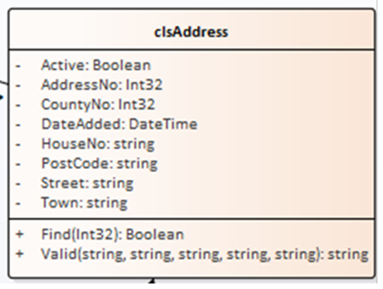

Let’s have a go at Find first.

A Quick Overview
We need to think a little about how this method is going to work.
Let’s assume that the table in the database contains the following data…
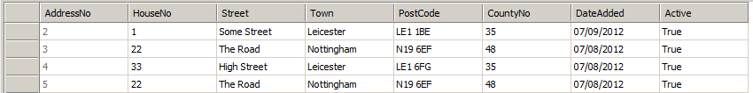
How the method works is that we will send it the value of a record’s primary key e.g. 2.
If record 2 is found the method will return a value of true, otherwise false.
As well as returning true or false the method also needs to return the data for all fields of the record being searched for.
For example
clsAddress AnAddress = new clsAddress();
AnAddress.Find(2);
string Street = AnAddress.Street;

Would set the value of the variable Street to “Some Street”.
What we will eventually do is set up some test data in the table that will be used to check that the method is returning the data we think it should be.

Creating the testing
The simple things first, we need to create a test to ensure the existence of the method.
Like so…
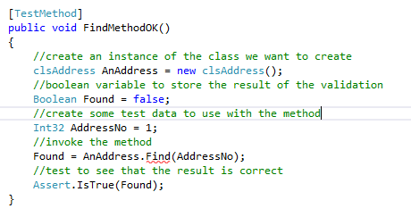
Find should be underlined in red as shown above.
Run the test – watch it fail and then fix it by creating the method.
It should still fail due to the code in the class not being right.
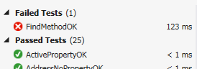
One of the features of TDD is that we are able to put in a quick fix to problems simply to make the test pass.
Look in the class clsAddress and change the auto generated code such that the test passes. The following code is an example of such a fix.
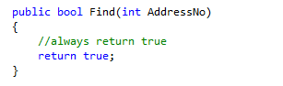
The test should now pass.
Modifying the Find method on clsAddress to always return true forces the test to pass but doesn’t exactly fix the problem in the long term.

Hard Coded Data Layer
Before we add any data to the database, we will start by hard coding the data layer to simulate the data being accessed.
We need to create a series of tests that search for the record and ensure that the correct data is being returned.
The first test in tstAddress is as follows…
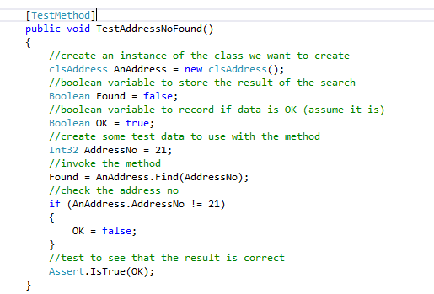
This test finds record number 21 and checks to see if the AddressNo property is also set to 21.
As usual the test should fail…
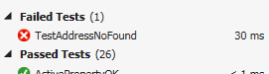
Let’s fix the problem to see if we can resolve the failed test.
To make this work we will hard code the result into the Find method’s function like so…
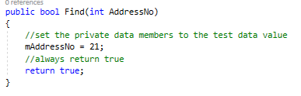
This code is basically rubbish but it allows us to write our testing.
- It can only ever search for record number 21
- It is not drawing any data from the database
You should already have a section of code that defines the property AddressNo in clsAddress, it should currently look like this…
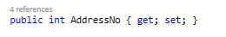
Next modify the public AddressNo property like so, creating a private member variable and a getter and setter …
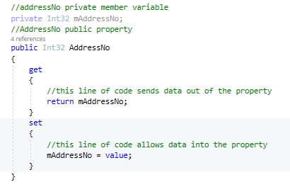
Let’s try the test again…
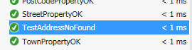
The good news is that it passes. The bad news is that the fix is still a bit rubbish, but we don’t care about that!
You will now need to create similar tests for each attribute in your class.
For example, here is the next test but this time for DateAdded…
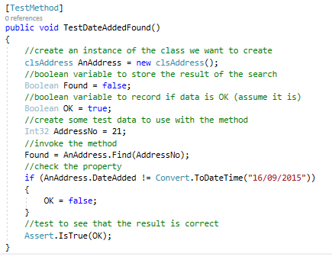
This test looks for record 21 and tests to see that it has a date of “16/09/2015”
You will need to modify the find function to provide the simulated data…
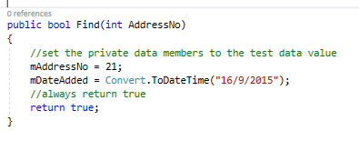
You will also need to modify the existing property to include a private member variable and a getter and setter…
For example…
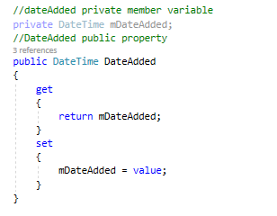
Data member
Public property
You will need to do this for each attribute in your class. Here is the full version of my testing code including code from last week at the top…

using System;
using Microsoft.VisualStudio.TestTools.UnitTesting;
using Class_Library;

namespace Test_Framework
{
[TestClass]
public class tstAddress
{
[TestMethod]
public void InstanceOK()
{
//create an instance of the class we want to create
clsAddress AnAddress = new clsAddress();
//test to see that it exists
Assert.IsNotNull(AnAddress);
}

[TestMethod]
public void ActivePropertyOK()
{
//create an instance of the class we want to create
clsAddress AnAddress = new clsAddress();
//create some test data to assign to the property
Boolean TestData = true;
//assign the data to the property
AnAddress.Active = TestData;
//test to see that the two values are the same
Assert.AreEqual(AnAddress.Active, TestData);
}

[TestMethod]
public void DateAddedPropertyOK()
{
//create an instance of the class we want to create
clsAddress AnAddress = new clsAddress();
//create some test data to assign to the property
DateTime TestData = DateTime.Now.Date;
//assign the data to the property
AnAddress.DateAdded = TestData;
//test to see that the two values are the same
Assert.AreEqual(AnAddress.DateAdded, TestData);
}

[TestMethod]
public void AddressNoPropertyOK()
{
//create an instance of the class we want to create
clsAddress AnAddress = new clsAddress();
//create some test data to assign to the property
Int32 TestData = 1;
//assign the data to the property
AnAddress.AddressNo = TestData;
//test to see that the two values are the same
Assert.AreEqual(AnAddress.AddressNo, TestData);
}

[TestMethod]
public void CountyNoPropertyOK()
{
//create an instance of the class we want to create
clsAddress AnAddress = new clsAddress();
//create some test data to assign to the property
Int32 TestData = 1;
//assign the data to the property
AnAddress.CountyNo = TestData;
//test to see that the two values are the same
Assert.AreEqual(AnAddress.CountyNo, TestData);
}

[TestMethod]
public void HouseNoPropertyOK()
{
//create an instance of the class we want to create
clsAddress AnAddress = new clsAddress();
//create some test data to assign to the property
string TestData = "21b";
//assign the data to the property
AnAddress.HouseNo = TestData;
//test to see that the two values are the same
Assert.AreEqual(AnAddress.HouseNo, TestData);
}

[TestMethod]
public void PostCodePropertyOK()
{
//create an instance of the class we want to create
clsAddress AnAddress = new clsAddress();
//create some test data to assign to the property
string TestData = "LE1 4AB";
//assign the data to the property
AnAddress.PostCode = TestData;
//test to see that the two values are the same
Assert.AreEqual(AnAddress.PostCode, TestData);
}

[TestMethod]
public void StreetPropertyOK()
{
//create an instance of the class we want to create
clsAddress AnAddress = new clsAddress();
//create some test data to assign to the property
string TestData = "Some Street";
//assign the data to the property
AnAddress.Street = TestData;
//test to see that the two values are the same
Assert.AreEqual(AnAddress.Street, TestData);
}

[TestMethod]
public void TownPropertyOK()
{
//create an instance of the class we want to create
clsAddress AnAddress = new clsAddress();
//create some test data to assign to the property
string TestData = "Leicester";
//assign the data to the property
AnAddress.Town = TestData;
//test to see that the two values are the same
Assert.AreEqual(AnAddress.Town, TestData);
}
NEW CODE FROM HERE
[TestMethod]
public void FindMethodOK()
{
//create an instance of the class we want to create
clsAddress AnAddress = new clsAddress();
//boolean variable to store the result of the validation
Boolean Found = false;
//create some test data to use with the method
Int32 AddressNo = 1;
//invoke the method
Found = AnAddress.Find(AddressNo);
//test to see that the result is correct
Assert.IsTrue(Found);
}

[TestMethod]
public void TestAddressNoFound()
{
//create an instance of the class we want to create
clsAddress AnAddress = new clsAddress();
//boolean variable to store the result of the search
Boolean Found = false;
//boolean variable to record if data is OK (assume it is)
Boolean OK = true;
//create some test data to use with the method
Int32 AddressNo = 21;
//invoke the method
Found = AnAddress.Find(AddressNo);
//check the address no
if (AnAddress.AddressNo != 21)
{
OK = false;
}
//test to see that the result is correct
Assert.IsTrue(OK);
}

[TestMethod]
public void TestStreetFound()
{
//create an instance of the class we want to create
clsAddress AnAddress = new clsAddress();
//boolean variable to store the result of the search
Boolean Found = false;
//boolean variable to record if data is OK (assume it is)
Boolean OK = true;
//create some test data to use with the method
Int32 AddressNo = 21;
//invoke the method
Found = AnAddress.Find(AddressNo);
//check the property
if (AnAddress.Street != "Test Street")
{
OK = false;
}
//test to see that the result is correct
Assert.IsTrue(OK);
}

[TestMethod]
public void TestTownFound()
{
//create an instance of the class we want to create
clsAddress AnAddress = new clsAddress();
//boolean variable to store the result of the search
Boolean Found = false;
//boolean variable to record if data is OK (assume it is)
Boolean OK = true;
//create some test data to use with the method
Int32 AddressNo = 21;
//invoke the method
Found = AnAddress.Find(AddressNo);
//check the property
if (AnAddress.Town != "Test Town")
{
OK = false;
}
//test to see that the result is correct
Assert.IsTrue(OK);
}

[TestMethod]
public void TestPostCodeFound()
{
//create an instance of the class we want to create
clsAddress AnAddress = new clsAddress();
//boolean variable to store the result of the search
Boolean Found = false;
//boolean variable to record if data is OK (assume it is)
Boolean OK = true;
//create some test data to use with the method
Int32 AddressNo = 21;
//invoke the method
Found = AnAddress.Find(AddressNo);
//check the property
if (AnAddress.PostCode != "XXX XXX")
{
OK = false;
}
//test to see that the result is correct
Assert.IsTrue(OK);
}

[TestMethod]
public void TestCountyNoFound()
{
//create an instance of the class we want to create
clsAddress AnAddress = new clsAddress();
//boolean variable to store the result of the search
Boolean Found = false;
//boolean variable to record if data is OK (assume it is)
Boolean OK = true;
//create some test data to use with the method
Int32 AddressNo = 21;
//invoke the method
Found = AnAddress.Find(AddressNo);
//check the property
if (AnAddress.CountyNo != 1)
{
OK = false;
}
//test to see that the result is correct
Assert.IsTrue(OK);
}

[TestMethod]
public void TestDateAddedFound()
{
//create an instance of the class we want to create
clsAddress AnAddress = new clsAddress();
//boolean variable to store the result of the search
Boolean Found = false;
//boolean variable to record if data is OK (assume it is)
Boolean OK = true;
//create some test data to use with the method
Int32 AddressNo = 21;
//invoke the method
Found = AnAddress.Find(AddressNo);
//check the property
if (AnAddress.DateAdded !=Convert.ToDateTime("16/09/2015"))
{
OK = false;
}
//test to see that the result is correct
Assert.IsTrue(OK);
}

[TestMethod]
public void TestActiveFound()
{
//create an instance of the class we want to create
clsAddress AnAddress = new clsAddress();
//boolean variable to store the result of the search
Boolean Found = false;
//boolean variable to record if data is OK (assume it is)
Boolean OK = true;
//create some test data to use with the method
Int32 AddressNo = 21;
//invoke the method
Found = AnAddress.Find(AddressNo);
//check the property
if (AnAddress.Active != true)
{
OK = false;
}
//test to see that the result is correct
Assert.IsTrue(OK);
}
}
}

Here is the finished code as it stands for the class clsAddress

using System;
using System.Collections.Generic;
using System.Linq;
using System.Text;

namespace Class_Library
{
public class clsAddress
{

//private data member for active
private Boolean mActive;
//public property for active
public bool Active
{
get
{
//return the private data
return mActive;
}
set
{
//set the private data
mActive = value;
}
}

//private date added data member
private DateTime mDateAdded;
//public property for date added
public DateTime DateAdded
{
get
{
//return the private data
return mDateAdded;
}
set
{
//set the private data
mDateAdded = value;
}
}

//private data member for the AddressNo property
private Int32 mAddressNo;
//public property for the address number
public int AddressNo
{
get
{
//return the private data
return mAddressNo;
}
set
{
//set the value of the private data member
mAddressNo = value;
}
}

//private data member for county no
private Int32 mCountyNo;
//public property for county no
public int CountyNo
{
get
{
//return the private data
return mCountyNo;
}
set
{
//set the private data
mCountyNo = value;
}
}

//private data member for HouseNo
private string mHouseNo;
//public property for house no
public string HouseNo
{
get
{
//return private data
return mHouseNo;
}
set
{
//set the private data
mHouseNo = value;
}
}

//private data member for post code
private string mPostCode;
//public property for post code
public string PostCode
{
get
{
//return the private data
return mPostCode;
}
set
{
//set the private data
mPostCode = value;
}
}

//private data member for street
private string mStreet;
//public data member for street
public string Street
{
get
{
//return the private data
return mStreet;
}
set
{
//set the private data
mStreet = value;
}
}

//private data member for town
private string mTown;
//public data member for Town
public string Town
{
get
{
//return the private data
return mTown;
}
set
{
//set the private data
mTown = value;
}
}

public bool Find(int AddressNo)
{
//set the private data members to the test data value
mAddressNo = 21;
mHouseNo = "123";
mStreet = "Test Street";
mTown = "Test Town";
mPostCode = "XXX XXX";
mCountyNo = 1;
mDateAdded = Convert.ToDateTime("16/9/2015");
mActive = true;
//always return true
return true;
}
}
}

Creating the Data Layer
At this stage all tests should pass, however there is still one important feature that is missing.
That is we are still not actually drawing the data from the database!
You will have created the table we need the other week…
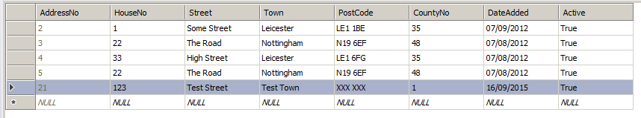
You will also need to create the following stored procedure…
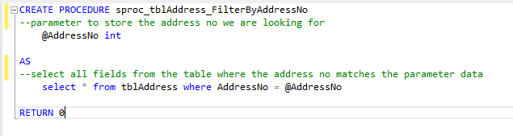
Once you have set these up, I would suggest you test the stored procedure to make sure that it works as planned. Use the SQL server object explorer to execute the stored procedure directly.
Make sure it is working before you go onto the next steps.

Modifying the Find Function
We now need to change the code for the Find method from this…
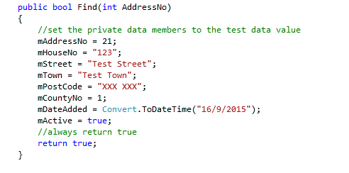
To this…
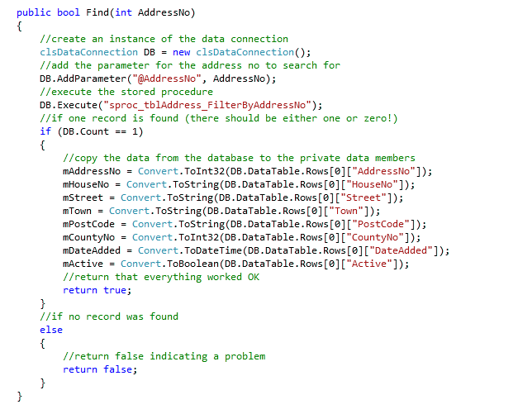
You should now see all your lovely tests fail, so what is the problem?
The problem is that our find method is looking to connect to the database, and we need to set up a few things to allow that to happen.

Connecting to the Database
There are several ways that we can connect to the database in this work.
The first approach is to use the online Azure portal, we did that the other week.
The next approach is to use Visual Studio to create tables and stored procedures. We did that just now.
The final tools are the class clsDataConnnection and Azure Connect which allow our running program to access Azure directly.

clsDataConnection
This class has been written for you to avoid you having to deal with the complexities of working with ADO.NET the technology used by Microsoft to link to the Azure SQL server database.
When you created your skeleton system, you will have followed the instructions for adding this class to your class library.
Notice in the following code how the object DB is used to manipulate the stored procedure and access the fields in the table…

Azure Connect
The last tool we need to use is a little program called Azure Connect. For your code to connect to Azure we need to provide it with the name of your server, then the name of your database, your username and password.
If you look at the settings in the Azure Portal for your database...
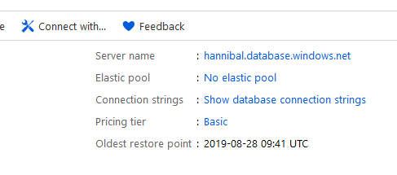
You will see a section for connection string, which will look something like this...

Connection Strings and Public Git Repositories
For this to work you need to replace the sections marked {username} and {password} with your own credentials.
So, here is the problem. If you add this code into your data connection and place it into a public repository, your plain text username and password is visible for all to see.
Even if you were using a private repository it likely still isn’t a good idea to store these details as plain text.
To get around this problem a program has been written called Azure Connect, available from the module web site.
When you run the program, you will see the following interface...
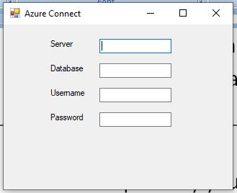
Enter here the details required by each field...
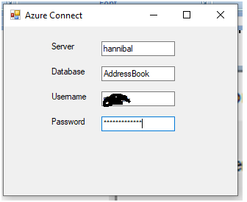
Azure Connect must be running at the same time as your program to allow your code to access the database.

Creating the Test Record
Even with all of this in place you will still find that your tests are still failing, why?
The problem is that all our tests are looking for a record 21, does such a record exist?
The answer is likely a no!
So, what is the problem?
Clearly, we need to ensure that the test data we are using actually exists.
You will need to match up the record ID in the tests to a record that actually exists, also you will need to set up test data in that record matching the test data you are looking for in the same test.
Do not carry on to the next section until all your tests are green!
Once you have all your tests running green you can be 100% sure that your code for finding records is working perfectly.

Adding the Presentation Layer
The final test of this functionality is to add a presentation layer to our work.
Last week you will have created a new web form called AnAddress.aspx…
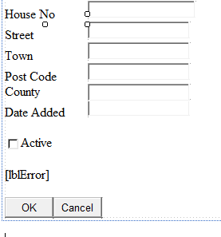
Modify the web form to include a field to enter the primary key and a button to execute the find operation…
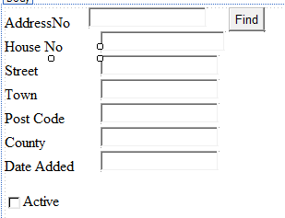

Remember to use the naming convention for the controls.
Text boxes e.g. house number would be txtHouseNo
Labels are lbl e.g. lblDateAdded
Buttons, btn e.g. btnFind
Double click the find button and add the following code…
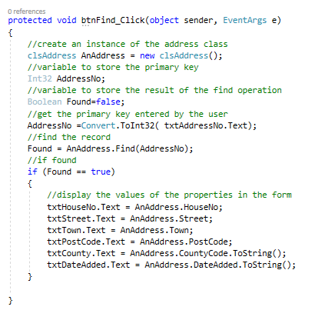
If you make the page the start page for the web site…
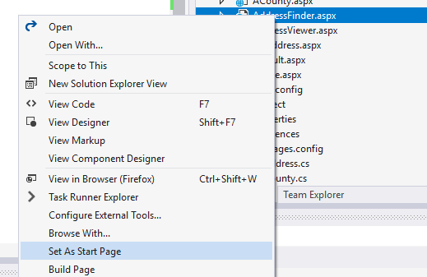
When you run the project, you should see a page like this…
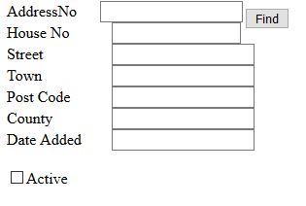
If you enter a valid primary key, you should see the data for that record displayed…
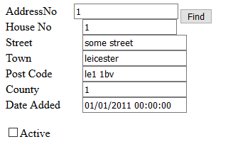

Questions
What happens if you enter a primary key value for a record that doesn’t exist?
How might you fix this to provide an error message?
What happens if you type a text value for the primary key?
Again, what it’s the problem and how might you fix this?

